Region
# Source: AI Source: Provided by: [Data Path: Persons Table -> ID Column: 1, Name_En Column: Motasem Essam] -> From: [ChatGPT] on [7/25/2026]
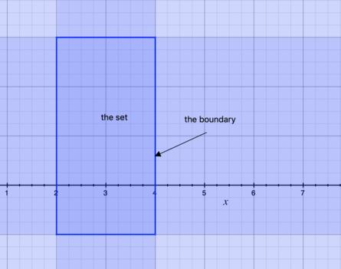
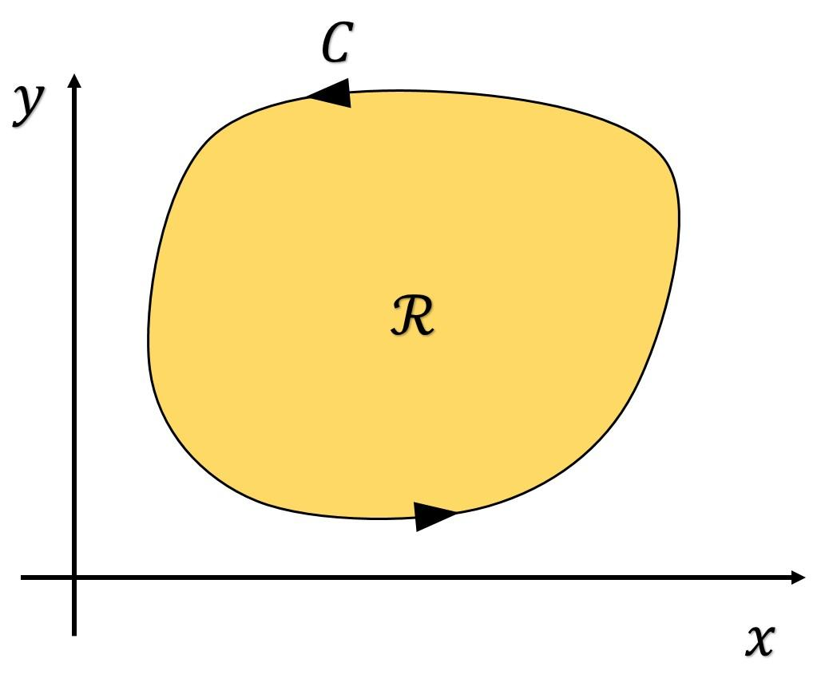
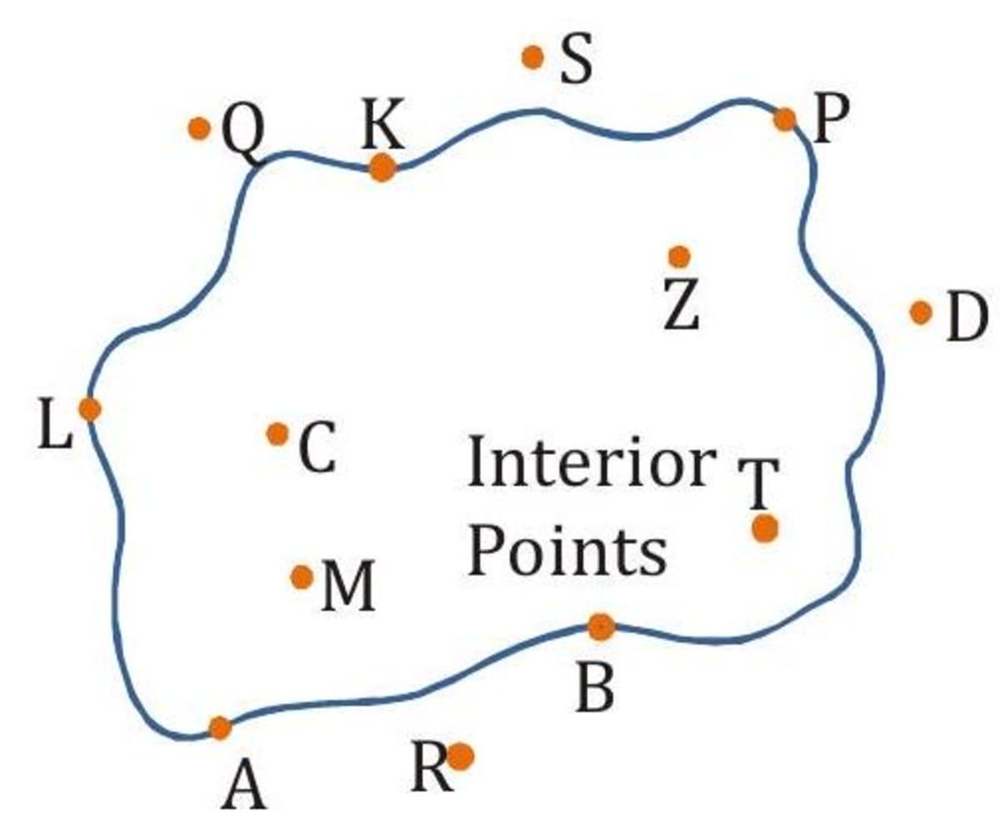
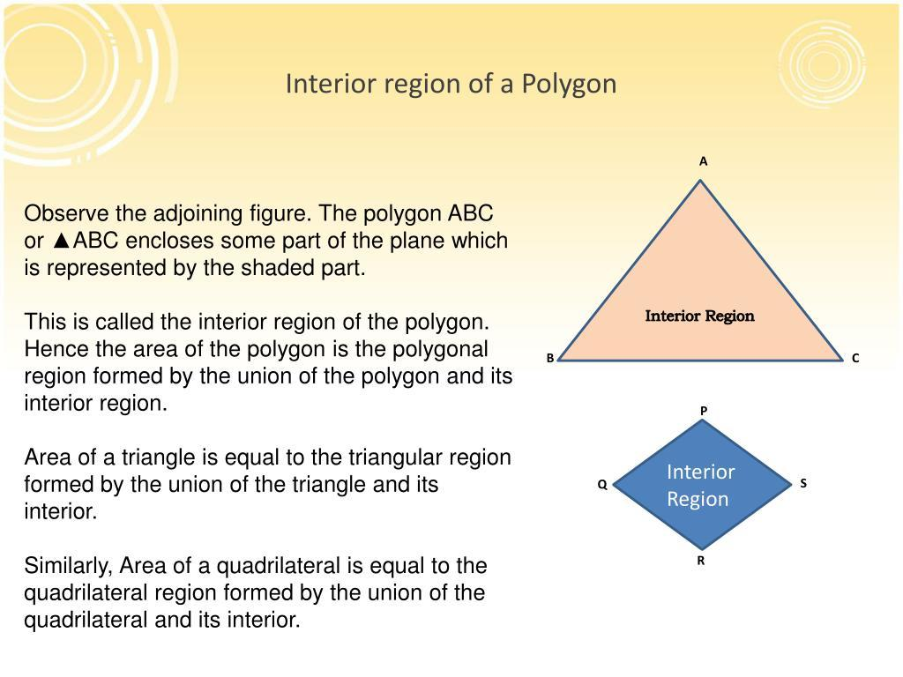
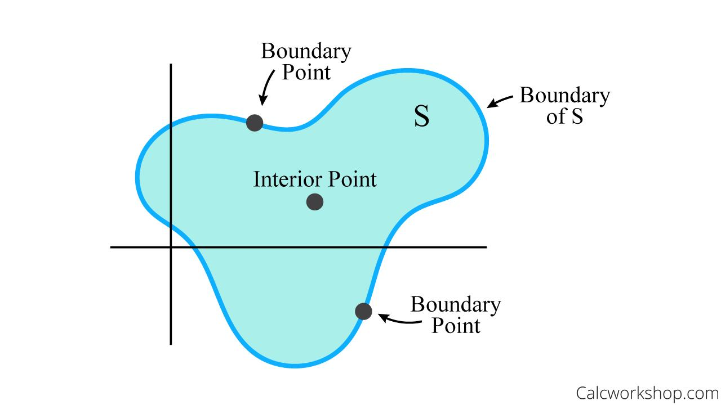

Definition
# Source: AI Source: Provided by: [Data Path: Persons Table -> ID Column: 1, Name_En Column: Motasem Essam] -> From: [ChatGPT] on [7/25/2026]
A Region is a portion of a plane that is enclosed, separated, or defined by geometric objects such as points, lines, line segments, rays, curves, or polygons.
A region occupies two-dimensional space and contains infinitely many points.
Unlike a line or a point, a region has area, although it does not have thickness.

Characteristics
# Source: AI Source: Provided by: [Data Path: Persons Table -> ID Column: 1, Name_En Column: Motasem Essam] -> From: [ChatGPT] on [7/25/2026]
A region:
- Exists on a plane.
- Occupies two-dimensional space.
- Has length and width, but no thickness.
- Contains infinitely many points.
- May be bounded or unbounded.
- May have regular or irregular boundaries.
- Can represent the inside or outside of geometric figures.

Illustration

Bounded Region
# Source: AI Source: Provided by: [Data Path: Persons Table -> ID Column: 1, Name_En Column: Motasem Essam] -> From: [ChatGPT] on [7/25/2026]
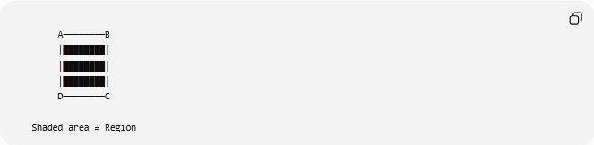
A────────B
│████████│
│████████│
│████████│
D────────C

Shaded area = Region
The shaded part represents a region enclosed by the rectangle.

Region Divided by a Line
# Source: AI Source: Provided by: [Data Path: Persons Table -> ID Column: 1, Name_En Column: Motasem Essam] -> From: [ChatGPT] on [7/25/2026]
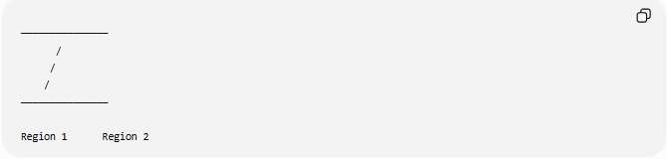
───────────────
/
/
/
───────────────

Region 1 Region 2
A line divides the plane into two regions (half-planes).

Mathematical Representation
# Source: AI Source: Provided by: [Data Path: Persons Table -> ID Column: 1, Name_En Column: Motasem Essam] -> From: [ChatGPT] on [7/25/2026]
A region is commonly represented as a set of points satisfying certain conditions.
Example:
The interior of a circle:
$$x^{2}+y^{2}<r^{2}$$
The boundary is excluded.
Including the boundary:
$$x^{2}+y^{2}≤r^{2}$$

Types of Regions

1. Bounded Region
# Source: AI Source: Provided by: [Data Path: Persons Table -> ID Column: 1, Name_En Column: Motasem Essam] -> From: [ChatGPT] on [7/25/2026]
A region completely enclosed by boundaries.
Examples:
- Triangle
- Rectangle
- Circle
- Polygon

2. Unbounded Region
# Source: AI Source: Provided by: [Data Path: Persons Table -> ID Column: 1, Name_En Column: Motasem Essam] -> From: [ChatGPT] on [7/25/2026]
A region extending infinitely.
Examples:
- Half-plane
- Exterior of a circle
- Exterior of a polygon

3. Interior Region
# Source: AI Source: Provided by: [Data Path: Persons Table -> ID Column: 1, Name_En Column: Motasem Essam] -> From: [ChatGPT] on [7/25/2026]
The points lying inside a closed figure.
Example:
The inside of a triangle.

4. Exterior Region
# Source: AI Source: Provided by: [Data Path: Persons Table -> ID Column: 1, Name_En Column: Motasem Essam] -> From: [ChatGPT] on [7/25/2026]
The points outside a closed figure.

5. Half-Plane
# Source: AI Source: Provided by: [Data Path: Persons Table -> ID Column: 1, Name_En Column: Motasem Essam] -> From: [ChatGPT] on [7/25/2026]
A line divides the plane into two infinite regions called half-planes.

Examples
# Source: AI Source: Provided by: [Data Path: Persons Table -> ID Column: 1, Name_En Column: Motasem Essam] -> From: [ChatGPT] on [7/25/2026]
Example 1
A rectangle encloses one bounded region.

Example 2
A circle divides the plane into:
- Interior region.
- Exterior region.
- Boundary (the circumference).

Example 3
A straight line divides the plane into two half-planes.

Region and Boundary
# Source: AI Source: Provided by: [Data Path: Persons Table -> ID Column: 1, Name_En Column: Motasem Essam] -> From: [ChatGPT] on [7/25/2026]
Every bounded region consists of:
- Interior.
- Boundary.
Example:
For a square:
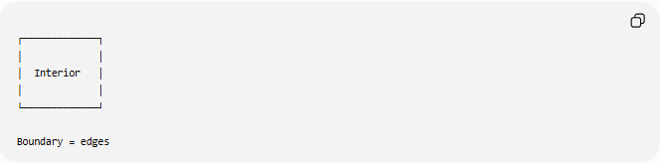
┌─────────────┐
│ │
│ Interior │
│ │
└─────────────┘

Boundary = edges

Area of a Region
# Source: AI Source: Provided by: [Data Path: Persons Table -> ID Column: 1, Name_En Column: Motasem Essam] -> From: [ChatGPT] on [7/25/2026]
Since a region occupies space, it has an area.
Examples:
Rectangle:
$$A=l×w$$
Circle:
$$A=πr^{2}$$
Triangle:
$$A=\frac{12}{b}h$$

Real-World Examples
# Source: AI Source: Provided by: [Data Path: Persons Table -> ID Column: 1, Name_En Column: Motasem Essam] -> From: [ChatGPT] on [7/25/2026]
Regions appear in:
- Rooms.
- Parks.
- Countries on maps.
- Computer screens.
- Land plots.
- Playing fields.
- Building floors.
- Garden layouts.

Applications
# Source: AI Source: Provided by: [Data Path: Persons Table -> ID Column: 1, Name_En Column: Motasem Essam] -> From: [ChatGPT] on [7/25/2026]
Regions are used in:
- Plane Geometry
- Coordinate Geometry
- Analytic Geometry
- Set Theory
- Topology
- Computer Graphics
- CAD (Computer-Aided Design)
- Geographic Information Systems (GIS)
- Engineering
- Architecture
- Surveying

Advantages
# Source: AI Source: Provided by: [Data Path: Persons Table -> ID Column: 1, Name_En Column: Motasem Essam] -> From: [ChatGPT] on [7/25/2026]
Studying regions helps to:
- Compute area.
- Describe enclosed spaces.
- Analyze geometric figures.
- Model real-world surfaces.
- Solve optimization problems.

Limitations
# Source: AI Source: Provided by: [Data Path: Persons Table -> ID Column: 1, Name_En Column: Motasem Essam] -> From: [ChatGPT] on [7/25/2026]
A region:
- Exists only in two dimensions.
- Has no thickness.
- May be difficult to describe algebraically if the boundary is irregular.

Comparison with Other Geometric Objects
# Source: AI Source: Provided by: [Data Path: Persons Table -> ID Column: 1, Name_En Column: Motasem Essam] -> From: [ChatGPT] on [7/25/2026]
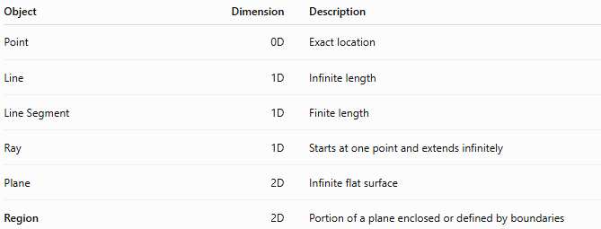
Object | Dimension | Description
Point | 0D | Exact location
Line | 1D | Infinite length
Line Segment | 1D | Finite length
Ray | 1D | Starts at one point and extends infinitely
Plane | 2D | Infinite flat surface
Region | 2D | Portion of a plane enclosed or defined by boundaries

Key Points
# Source: AI Source: Provided by: [Data Path: Persons Table -> ID Column: 1, Name_En Column: Motasem Essam] -> From: [ChatGPT] on [7/25/2026]
- A Region is a portion of a plane.
- It occupies two-dimensional space.
- It may be:
  - Bounded.
  - Unbounded.
  - Interior.
  - Exterior.
- A line divides the plane into two regions.
- Closed figures enclose bounded regions that have measurable area.

Conclusion
# Source: AI Source: Provided by: [Data Path: Persons Table -> ID Column: 1, Name_En Column: Motasem Essam] -> From: [ChatGPT] on [7/25/2026]
A Region is a portion of a plane defined or enclosed by geometric boundaries such as lines, curves, or polygons. Regions occupy two-dimensional space, contain infinitely many points, and may be bounded or unbounded. They are fundamental in plane geometry, coordinate geometry, analytic geometry, topology, GIS, engineering, architecture, surveying, CAD, and computer graphics, where they are used to represent surfaces, compute areas, analyze spatial relationships, and model real-world environments.

